Clases semana 07/08 al 11/08

**EA 1: 07/08 al 18/08**

Explanation in Spanish:

<https://www.blueblocnotes.com/grammar/present-tenses/present-continuous>

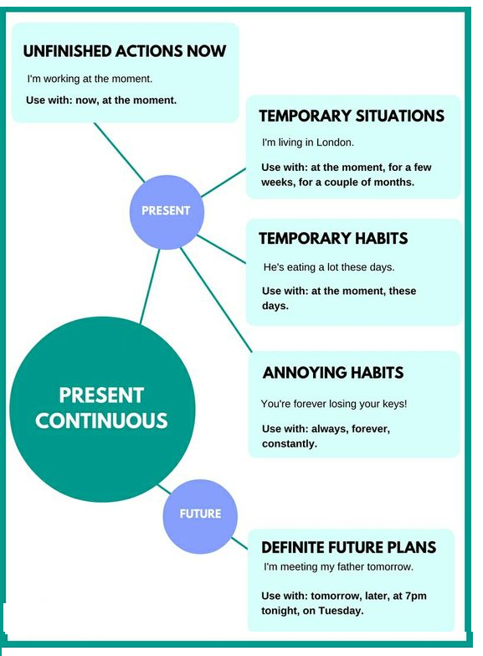

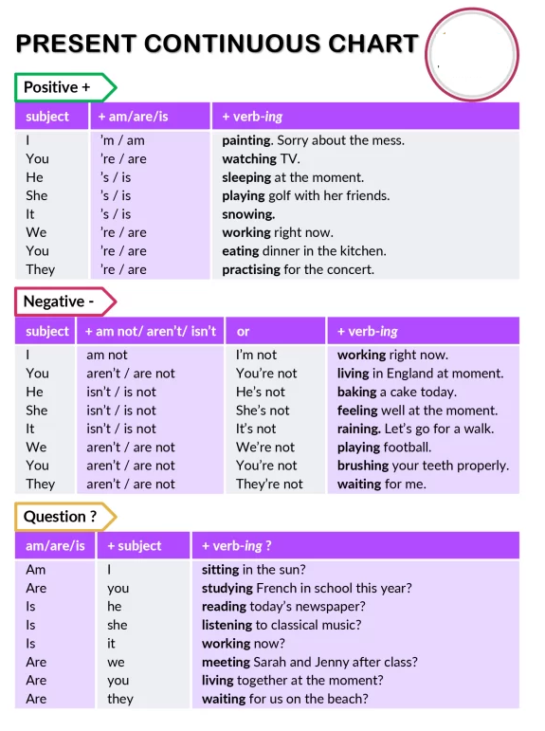

Let´s practice:

<https://first-english.org/english_learning/english_tenses/present_progressive/a_present_progressive_exercises.htm>

Clases semana 14/08 al 18/08

**Wh + to be + S + v-ing + compl?**

What time is she leaving?

Where are they going?

What are you looking for?

Who are we meeting?

<https://www.elllo.org/english/grammar/L3-03-present-continuous.htm>

Watch the video and answer the questions

<https://www.youtube.com/watch?v=8TXx-RrXYVA>

Oral work: In pairs, ask and answer questions: What are the members of your family doing?

Extra practice: **Compare** the use of the Present Simple and Present Continuous

<https://www.blueblocnotes.com/grammar/present-tenses/present-simple-and-continuous>

<https://first-english.org/english_learning/english_tenses/comparison_tenses/10_test_simple_present_present_or_present_continuous.htm>